> fileUrl <- "http://archive.ics.uci.edu/ml/machine-learning-databases/auto-mpg/auto-mpg.data"

> dataFrame<-NULL

> dataFrame <- read.table(fileUrl, header=FALSE, na.strings = c('NA','?'), stringsAsFactors = TRUE)

> names(dataFrame) <- c("Mpg", "Cylinders", "Displacement", "Horsepower", "Weight", "Acceleration", "ModelYear", "Origin", "CarName")

> #checking the datatype of all columns

> sapply(dataFrame, class)

Mpg Cylinders Displacement Horsepower Weight Acceleration ModelYear

"numeric" "integer" "numeric" "numeric" "numeric" "numeric" "integer"

Origin CarName

"integer" "factor"

> # Checking NA in columns

> colSums(is.na(dataFrame))

Mpg Cylinders Displacement Horsepower Weight Acceleration ModelYear

0 0 0 6 0 0 0

Origin CarName

0 0

**Found Horsepower have 6 NA values**

**#Here we found HorsePower have 6 missing value. Will replace it with median is more appropriate here.**

> horsepower_med<-median(dataFrame$Horsepower, na.rm = TRUE)

> dataFrame$Horsepower[is.na(dataFrame$Horsepower)]<-horsepower_med

> head(dataFrame)

Mpg Cylinders Displacement Horsepower Weight Acceleration ModelYear Origin

1 18 8 307 130 3504 12.0 70 1

2 15 8 350 165 3693 11.5 70 1

3 18 8 318 150 3436 11.0 70 1

4 16 8 304 150 3433 12.0 70 1

5 17 8 302 140 3449 10.5 70 1

6 15 8 429 198 4341 10.0 70 1

CarName

1 chevrolet chevelle malibu

2 buick skylark 320

3 plymouth satellite

4 amc rebel sst

5 ford torino

6 ford galaxie 500

**# 2. Identify all of the categorical variables,**

**# all of the numeric variables**

**# Store it in the variables below.**

**# 2 points**

> sapply(dataFrame, class)

Mpg Cylinders Displacement Horsepower Weight Acceleration ModelYear

"numeric" "integer" "numeric" "numeric" "numeric" "numeric" "integer"

Origin CarName

"factor" "factor"

> #ORIGIN, CYLINDERS, MODELYEAR are catagorical variables

> dataFrame$Origin <- as.factor(dataFrame$Origin)

> dataFrame$Cylinders <- as.factor(dataFrame$Cylinders)

> dataFrame$ModelYear <- as.factor(dataFrame$ModelYear)

> sapply(dataFrame, class)

Mpg Cylinders Displacement Horsepower Weight Acceleration ModelYear

"numeric" "factor" "numeric" "numeric" "numeric" "numeric" "factor"

Origin CarName

"factor" "factor"

> numVars<-names(dataFrame)[sapply(dataFrame, is.numeric)]

> print(numVars)

[1] "Mpg" "Displacement" "Horsepower" "Weight" "Acceleration"

> catVars<-names(dataFrame)[sapply(dataFrame, is.factor)]

> print(catVars)

[1] "Cylinders" "ModelYear" "Origin" "CarName"

**# 3. Identify the appropriate descriptive statistics and graph for this data set.**

**# Execute on those and use the comments to discuss relevant relationships or insights discovered.**

**# 2 points**

> #summary of whole data set.

> summary(dataFrame)

Mpg Cylinders Displacement Horsepower Weight Acceleration

Min. : 9.00 3: 4 Min. : 68.0 Min. : 46.0 Min. :1613 Min. : 8.00

1st Qu.:17.50 4:204 1st Qu.:104.2 1st Qu.: 76.0 1st Qu.:2224 1st Qu.:13.82

Median :23.00 5: 3 Median :148.5 Median : 93.5 Median :2804 Median :15.50

Mean :23.51 6: 84 Mean :193.4 Mean :104.3 Mean :2970 Mean :15.57

3rd Qu.:29.00 8:103 3rd Qu.:262.0 3rd Qu.:125.0 3rd Qu.:3608 3rd Qu.:17.18

Max. :46.60 Max. :455.0 Max. :230.0 Max. :5140 Max. :24.80

ModelYear Origin CarName

73 : 40 1:249 ford pinto : 6

78 : 36 2: 70 amc matador : 5

76 : 34 3: 79 ford maverick : 5

82 : 31 toyota corolla: 5

75 : 30 amc gremlin : 4

70 : 29 amc hornet : 4

(Other):198 (Other) :369

> for(k in catVars){

+ if(k!= colnames(dataFrame[9])){ ##not loop on Carname col

+ barplot(table(dataFrame[[k]]), xlab=k, las = 1)

+ }

+ }

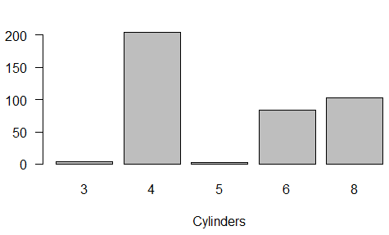

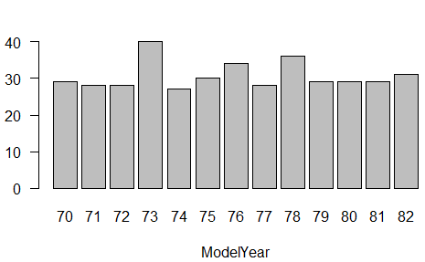

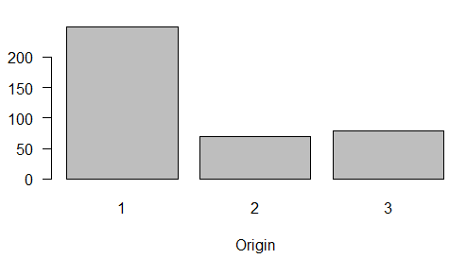

**# Results and Information from BAR Chart -**

**# column cylinders has 200+ records at 4 category.**

**# column Origin has 250+ records at 1 category.**

**# column Model Year is almost uniformly distributed, except at 73, 76 and 78. Max records are at 73**

**#For numeric columns I will use box-plot, histogram and plot between variables**

**#BOXPLOT** **#Histogram #Plot**

|  |
| --- |
| for (i in numVars){  + lable <- paste("Box-plot of", i)  + boxplot(dataFrame[[i]], main = lable, xlab = i, las = 1)  + # histograms  + hist(dataFrame[[i]], main = i, xlab = i)  +  + #Plot  + plot(y=dataFrame$Mpg, x=dataFrame[[i]], ylab = "Miles per gallon", xlab = i, las = 1)  + } |
|  |
|  |

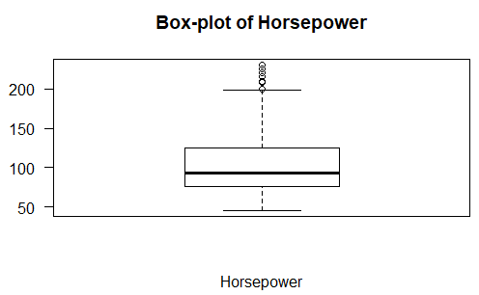 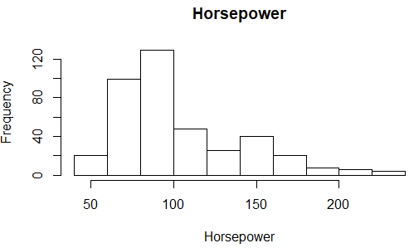 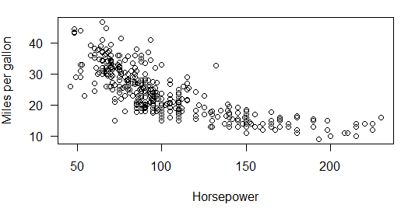

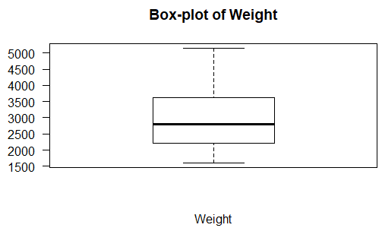 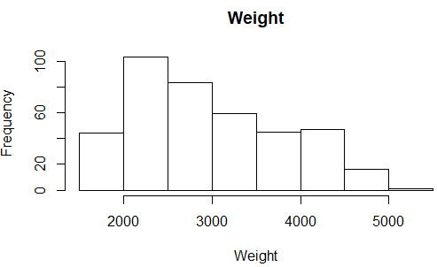 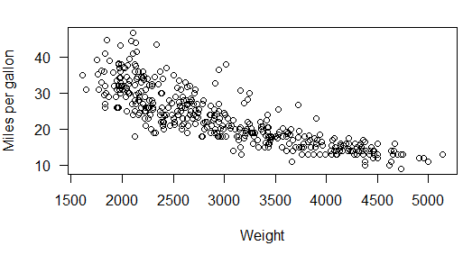

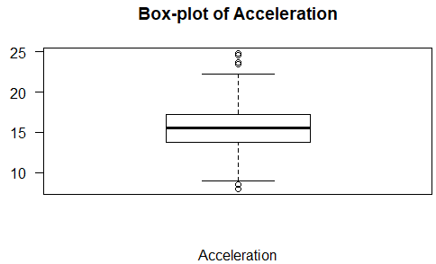 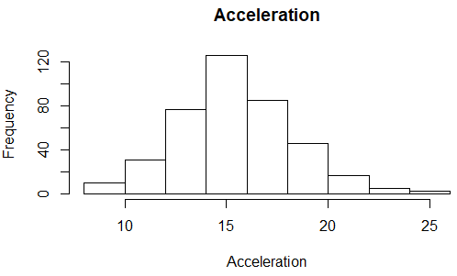 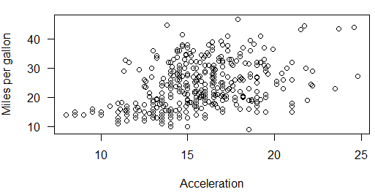

**# Results and Information from BOXPLOT -**

**# 1 outlier in MPG value around 46 and a half numbers of cars have good Miles per gallon about 23.**

**# many outliers cars have more than 200 horsepower.**

**# weight seems perfect no outliers are present from min 1613, median 2804 to max 5140.**

**# In acceleration some lower and upper outliers and mean 15.50.**

**# Results and Information from histograms -**

**# from all histograms we can say Acceleration is more seem like Normally Distributed.**

**# and others are like left-shifted, lower values have more frequencies like positively skewed Mode<Median<Mean on the x-axis.**

**# Results and Information from the plots -**

**# acceleration has a positive correlation with Mpg(Miles per gallon)**

**# and others (Displacement, Horsepower, and Weighthave) have negative correlation with the Mpg((Miles per gallon) and non-linear.**

**# 4. Create a correlation matrix for all of the numeric variables.**

**# 2 points**

> corMatrix <- cor(dataFrame[numVars])

> corMatrix

Mpg Displacement Horsepower Weight Acceleration

Mpg 1.0000000 -0.8042028 -0.7734532 -0.8317409 0.4202889

Displacement -0.8042028 1.0000000 0.8957782 0.9328241 -0.5436841

Horsepower -0.7734532 0.8957782 1.0000000 0.8624424 -0.6865897

Weight -0.8317409 0.9328241 0.8624424 1.0000000 -0.4174573

Acceleration 0.4202889 -0.5436841 -0.6865897 -0.4174573 1.0000000

> corrplot(corMatrix, method = "circle", diag = TRUE)

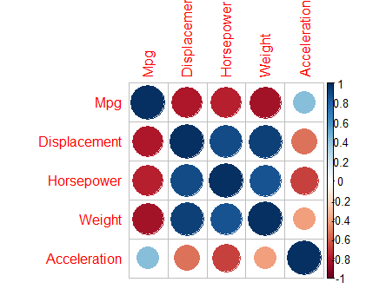

**# 5. Create a box plot of mpg versus origin**

**# 2 points**

boxplot(dataFrame$Mpg~dataFrame$Origin, xlab = 'Origin', ylab = 'Mpg(Miles per gallon)', las = 1)

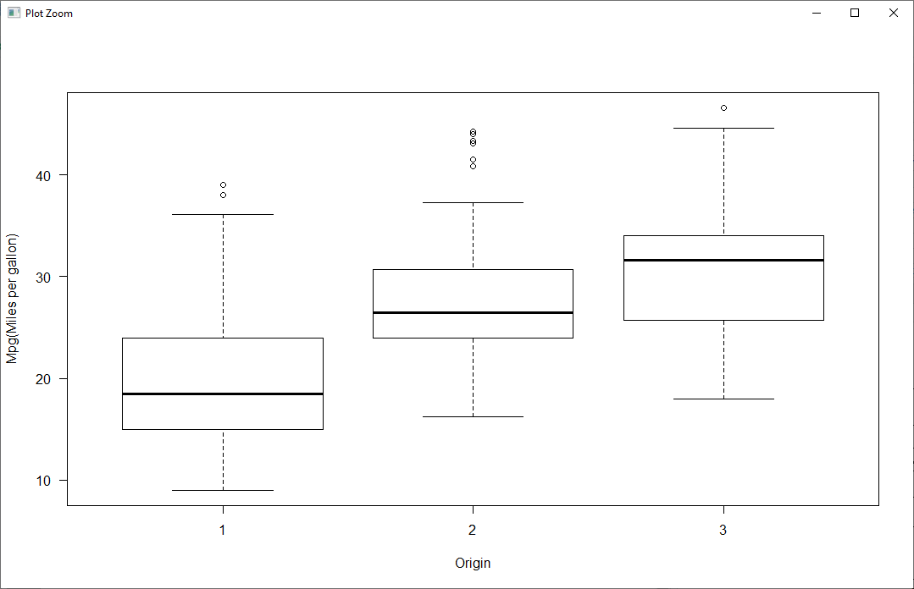

**# 6. Divide the data into a train/test set (80% and 20% respectively) using stratified sampling**

**# 2 points**

> library('caret')

> set.seed(42)

> indexs <- createDataPartition(y = dataFrame$Mpg, times = 1, p = 0.8, list = FALSE)

> train_DF <- dataFrame[indexs,]

> test_DF <- dataFrame[-indexs,]

> head(train_DF)

Mpg Cylinders Displacement Horsepower Weight Acceleration ModelYear Origin

1 18 8 307 130 3504 12.0 70 1

3 18 8 318 150 3436 11.0 70 1

4 16 8 304 150 3433 12.0 70 1

5 17 8 302 140 3449 10.5 70 1

6 15 8 429 198 4341 10.0 70 1

7 14 8 454 220 4354 9.0 70 1

CarName

1 chevrolet chevelle malibu

3 plymouth satellite

4 amc rebel sst

5 ford torino

6 ford galaxie 500

7 chevrolet impala

**# 7. Fit a linear model to the data using the numeric variables only. Calculate the R**2 on the test set.**

**# 3 points**

> #Liner model

> groupvars<-numVars[-1]

> # This returns the formula:

> modelFormula <- as.formula(paste('Mpg', paste(groupvars, collapse=" + "), sep=" ~ "))

> model <- lm(modelFormula, data = train_DF)# build the model

> summary(model)

Call:

lm(formula = modelFormula, data = train_DF)

Residuals:

Min 1Q Median 3Q Max

-11.4763 -2.8329 -0.2614 2.1657 14.1051

Coefficients:

Estimate Std. Error t value Pr(>|t|)

(Intercept) 45.9099180 2.6355691 17.419 < 2e-16 ***

Displacement -0.0080674 0.0073871 -1.092 0.2756

Horsepower -0.0430874 0.0178473 -2.414 0.0163 *

Weight -0.0051874 0.0008706 -5.959 6.79e-09 ***

Acceleration -0.0720721 0.1335929 -0.539 0.5899

---

Signif. codes: 0 ‘***’ 0.001 ‘**’ 0.01 ‘*’ 0.05 ‘.’ 0.1 ‘ ’ 1

Residual standard error: 4.143 on 316 degrees of freedom

Multiple R-squared: 0.7137, Adjusted R-squared: 0.71

F-statistic: 196.9 on 4 and 316 DF, p-value: < 2.2e-16

> Mpg_pred<-predict(model, test_DF)

> #residual = predict - actual

> res<- Mpg_pred - test_DF$Mpg

> sse <- sum(res**2)

> #sst = sum((y-yhat)**2)

> sst<- sum((test_DF$Mpg-mean(test_DF$Mpg))**2)

> rSq <- 1-sse/sst

> rSq #R**2 on test data is 0.668995

[1] **0.668995**

**# 8. Programmatically identify and remove the non-significant variables (alpha = .05). Fit a new model with those variables removed.**

**# Calculate the R**2 on the test set with the new model. Did this improve performance?**

**# 4 points**

> xvars1 <- rownames(summary(model)$coefficients[summary(model)$coefficients[,4]<0.05,])[-1]

> xvars1 #significant variables P-value < (alpha = .05)

[1] "Horsepower" "Weight"

>

> modelFormula1 <- as.formula(paste('Mpg', paste(xvars1, collapse=" + "), sep=" ~ "))

> model1 <- lm(modelFormula1, data = train_DF)

> summary(model1)

Call:

lm(formula = modelFormula1, data = train_DF)

Residuals:

Min 1Q Median 3Q Max

-11.0163 -2.7286 -0.2674 2.2123 13.7605

Coefficients:

Estimate Std. Error t value Pr(>|t|)

(Intercept) 45.6891167 0.8591385 53.180 < 2e-16 ***

Horsepower -0.0447472 0.0121543 -3.682 0.000272 ***

Weight -0.0059536 0.0005483 -10.859 < 2e-16 ***

---

Signif. codes: 0 ‘***’ 0.001 ‘**’ 0.01 ‘*’ 0.05 ‘.’ 0.1 ‘ ’ 1

Residual standard error: 4.139 on 318 degrees of freedom

Multiple R-squared: 0.7125, Adjusted R-squared: 0.7107

F-statistic: 394 on 2 and 318 DF, p-value: < 2.2e-16

>

> Mpg_pred1<-predict(model1, test_DF)

>

> #residual = predict - actual

> res1<- Mpg_pred1 - test_DF$Mpg

> sse1 <- sum(res1**2)

> #sst = sum((y-yhat)**2)

> sst1<- sum((test_DF$Mpg-mean(test_DF$Mpg))**2)

> rSq1 <- 1-sse1/sst1

> rSq1 #R**2 on test data is 0.6711464

[1] 0.6711464

>

> #The performance of the model does seems improve when compared to the previous model.

**# 9. Attempt to fit a model on all of the relevant independent variables (including carName).**

**# Then calculate the R**2 on a test set. You will likely encounter an error.**

**# Explain why this error occurs. Fix this error.**

**# 4 points**

> xvars2<-c(xvars1,catVars)

> xvars2

[1] "Horsepower" "Weight" "Cylinders" "ModelYear" "Origin" "CarName"

> modelFormula2 <- as.formula(paste('Mpg', paste(xvars2, collapse=" + "), sep=" ~ "))

>

> #Creating model(Name is model9 for question-9)

> model9 <- lm(modelFormula2, data = train_DF)

> summary(model9)

> Mpg_pred9<-predict(model9, test_DF)

Error in model.frame.default(Terms, newdata, na.action = na.action, xlev = object$xlevels) :

factor CarName has new levels amc concord dl, amc spirit dl, audi 100 ls, buick century luxus (sw), buick lesabre custom, ………..

**# Error is due to carName variable have some value or names that are new or unseen in the training set.**

**# and there is no dummy variables for the same records. Hence, when the test record**

**# tries to predict the mpg for cars from test data which are not present, an error is occurred.**

**# One soluction: carName variable should not be considered in the model.**

> xVars3 <- c(xvars2,catVars[which(catVars != "CarName")])

> modelFormula91 <- as.formula(paste('Mpg', paste(xVars3, collapse=" + "), sep=" ~ "))

> model91 <- lm(modelFormula91, data = train_DF)

> summary(model91)

Call:

lm(formula = modelFormula91, data = train_DF)

Residuals:

Min 1Q Median 3Q Max

-6.6648 -1.6245 0.0365 1.4584 11.7346

Coefficients:

Estimate Std. Error t value Pr(>|t|)

(Intercept) 31.7814353 2.0192279 15.739 < 2e-16 ***

Horsepower -0.0282616 0.0105130 -2.688 0.00758 **

Weight -0.0051487 0.0005292 -9.730 < 2e-16 ***

Cylinders4 7.0446997 1.4584647 4.830 2.18e-06 ***

Cylinders5 6.5546163 2.4970834 2.625 0.00911 **

Cylinders6 4.9711326 1.5391303 3.230 0.00138 **

Cylinders8 7.8472801 1.6695440 4.700 3.97e-06 ***

ModelYear71 0.8422658 0.8650809 0.974 0.33103

ModelYear72 -0.7989975 0.8547878 -0.935 0.35068

ModelYear73 -0.7830053 0.7592606 -1.031 0.30324

ModelYear74 1.0196530 0.9137662 1.116 0.26537

ModelYear75 0.9300840 0.9231949 1.007 0.31452

ModelYear76 1.0612362 0.8608552 1.233 0.21863

ModelYear77 2.5852670 0.8768896 2.948 0.00345 **

ModelYear78 2.6035068 0.8306218 3.134 0.00189 **

ModelYear79 4.8236572 0.8684570 5.554 6.15e-08 ***

ModelYear80 8.9633727 0.9261207 9.678 < 2e-16 ***

ModelYear81 6.0850953 0.9185001 6.625 1.61e-10 ***

ModelYear82 7.3244742 0.9002053 8.136 1.09e-14 ***

Origin2 1.5123700 0.5068614 2.984 0.00308 **

Origin3 1.4309273 0.5047034 2.835 0.00489 **

---

Signif. codes: 0 ‘***’ 0.001 ‘**’ 0.01 ‘*’ 0.05 ‘.’ 0.1 ‘ ’ 1

Residual standard error: 2.76 on 300 degrees of freedom

Multiple R-squared: 0.8794, Adjusted R-squared: 0.8713

F-statistic: 109.3 on 20 and 300 DF, p-value: < 2.2e-16

>

>

> Mpg_pred91<-predict(model91, test_DF)

>

> #residual = predict - actual

> res91<- Mpg_pred91 - test_DF$Mpg

> sse91 <- sum(res91**2)

> #sst = sum((y-yhat)**2)

> sst91<- sst ##always same

> rSq91 <- 1-sse91/sst91

> rSq91#R**2 on test data is 0.8376818

[1] 0.8376818

**## Here we go we have biger R**2 that means this model that the regression line perfectly fits the data**

**# 10. Determine the relationship between model year and mpg.**

**# Interpret this relationship.**

**# Theorize why this relationship might occur.**

**# 4 points**

> average_mpg_year<- tapply(dataFrame$Mpg,dataFrame$ModelYear,mean)

> yearvalue<-unique(dataFrame$ModelYear)

> numericyear<-as.numeric(levels(yearvalue))[yearvalue]

> cor_mpg_myears<-cor(numericyear,average_mpg_year, method = "pearson")

> cor_mpg_myears #0.884

[1] 0.8839478

>

> data= data.frame(yearvalue,average_mpg_year)

> plot(data, xlab="Years", ylab=" Miles per gallon")

> title (" Miles per gallon over Years")

> points(average_mpg_year,col="blue",pch=19)

> lines(average_mpg_year)

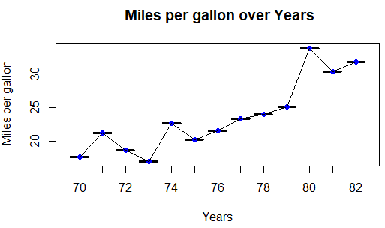

**#highly positive correlation that means they have a positive increasing relationship between Mpg and Model years.**

**# and seems logically correct because as per market demand for better Miles per gallon.(though a couple of drops are seen, the overall mpg is increasing)**

**#so every year companies try to give better performance in this direction that we can see in the above plot.**

**# 11. Using only the variables provided, build the best linear model**

**# you can (as measured by R**2 on the test data)**

**# Record the value obtained in the comments below. Make sure to show all your code.**

**# Record the best R**2 value on the test set in the comments below.**

**# My Best R**2 value: 0.8640147**

**# 4 points**

> library(leaps)

> squ_model <- lm(Mpg ~ 1 + Cylinders + Displacement + I(Displacement^2) + Horsepower + I(Horsepower^2) +Weight + I(Weight^2)+ Acceleration + I(Acceleration^2)+ModelYear + Origin, data=train_DF)

> summary(squ_model)

Call:

lm(formula = Mpg ~ 1 + Cylinders + Displacement + I(Displacement^2) +

Horsepower + I(Horsepower^2) + Weight + I(Weight^2) + Acceleration +

I(Acceleration^2) + ModelYear + Origin, data = train_DF)

Residuals:

Min 1Q Median 3Q Max

-6.6295 -1.3657 -0.0022 1.3509 9.7557

Coefficients:

Estimate Std. Error t value Pr(>|t|)

(Intercept) 6.668e+01 5.743e+00 11.612 < 2e-16 ***

Cylinders4 7.885e+00 1.462e+00 5.394 1.42e-07 ***

Cylinders5 8.972e+00 2.313e+00 3.879 0.000129 ***

Cylinders6 8.148e+00 1.824e+00 4.467 1.13e-05 ***

Cylinders8 8.835e+00 2.135e+00 4.138 4.57e-05 ***

Displacement -3.798e-02 2.282e-02 -1.664 0.097159 .

I(Displacement^2) 5.496e-05 3.943e-05 1.394 0.164443

Horsepower -7.423e-02 4.116e-02 -1.804 0.072331 .

I(Horsepower^2) 9.255e-05 1.493e-04 0.620 0.535688

Weight -1.413e-02 2.754e-03 -5.131 5.24e-07 ***

I(Weight^2) 1.623e-06 3.742e-07 4.337 1.99e-05 ***

Acceleration -1.881e+00 5.334e-01 -3.528 0.000486 ***

I(Acceleration^2) 5.112e-02 1.577e-02 3.241 0.001327 **

ModelYear71 1.282e-01 8.217e-01 0.156 0.876167

ModelYear72 -2.624e-01 7.885e-01 -0.333 0.739531

ModelYear73 -7.414e-01 7.023e-01 -1.056 0.291958

ModelYear74 9.328e-01 8.514e-01 1.096 0.274119

ModelYear75 1.206e+00 8.406e-01 1.434 0.152587

ModelYear76 1.388e+00 7.887e-01 1.760 0.079431 .

ModelYear77 2.793e+00 8.080e-01 3.456 0.000628 ***

ModelYear78 3.095e+00 7.580e-01 4.083 5.73e-05 ***

ModelYear79 5.158e+00 7.972e-01 6.471 4.07e-10 ***

ModelYear80 9.126e+00 8.284e-01 11.017 < 2e-16 ***

ModelYear81 6.205e+00 8.404e-01 7.383 1.60e-12 ***

ModelYear82 7.568e+00 8.142e-01 9.295 < 2e-16 ***

Origin2 4.803e-01 5.273e-01 0.911 0.363171

Origin3 4.806e-01 5.021e-01 0.957 0.339271

---

Signif. codes: 0 ‘***’ 0.001 ‘**’ 0.01 ‘*’ 0.05 ‘.’ 0.1 ‘ ’ 1

Residual standard error: 2.432 on 294 degrees of freedom

Multiple R-squared: 0.9082, Adjusted R-squared: 0.9001

F-statistic: 111.9 on 26 and 294 DF, p-value: < 2.2e-16

>

> mybest_model <- step(squ_model, scope = list(lower= Mpg~1, upper= Mpg ~ 1 + Cylinders + Displacement + I(Displacement^2) + Horsepower + I(Horsepower^2) +Weight + I(Weight^2)+ Acceleration + I(Acceleration^2)+ModelYear + Origin, data=train_DF), direction = 'both')

Start: AIC=596.29

Mpg ~ 1 + Cylinders + Displacement + I(Displacement^2) + Horsepower +

I(Horsepower^2) + Weight + I(Weight^2) + Acceleration + I(Acceleration^2) +

ModelYear + Origin

Df Sum of Sq RSS AIC

- Origin 2 6.68 1745.3 593.53

- I(Horsepower^2) 1 2.27 1740.9 594.71

<none> 1738.6 596.29

- I(Displacement^2) 1 11.49 1750.1 596.41

- Displacement 1 16.38 1755.0 597.30

- Horsepower 1 19.23 1757.8 597.83

- I(Acceleration^2) 1 62.12 1800.7 605.56

- Acceleration 1 73.59 1812.2 607.60

- I(Weight^2) 1 111.24 1849.8 614.20

- Cylinders 4 185.52 1924.1 620.84

- Weight 1 155.70 1894.3 621.83

- ModelYear 12 2261.76 4000.4 839.79

Step: AIC=593.53

Mpg ~ Cylinders + Displacement + I(Displacement^2) + Horsepower +

I(Horsepower^2) + Weight + I(Weight^2) + Acceleration + I(Acceleration^2) +

ModelYear

Df Sum of Sq RSS AIC

- I(Horsepower^2) 1 1.45 1746.7 591.79

<none> 1745.3 593.53

- Horsepower 1 16.97 1762.2 594.63

- I(Displacement^2) 1 21.67 1766.9 595.49

+ Origin 2 6.68 1738.6 596.29

- Displacement 1 35.02 1780.3 597.90

- I(Acceleration^2) 1 69.66 1814.9 604.09

- Acceleration 1 82.34 1827.6 606.32

- I(Weight^2) 1 108.48 1853.7 610.88

- Weight 1 152.94 1898.2 618.49

- Cylinders 4 211.90 1957.2 622.31

- ModelYear 12 2388.37 4133.6 846.31

Step: AIC=591.79

Mpg ~ Cylinders + Displacement + I(Displacement^2) + Horsepower +

Weight + I(Weight^2) + Acceleration + I(Acceleration^2) +

ModelYear

Df Sum of Sq RSS AIC

<none> 1746.7 591.79

+ I(Horsepower^2) 1 1.45 1745.3 593.53

+ Origin 2 5.86 1740.9 594.71

- I(Displacement^2) 1 30.80 1777.5 595.40

- Displacement 1 40.43 1787.2 597.14

- I(Acceleration^2) 1 78.52 1825.2 603.91

- Horsepower 1 85.75 1832.5 605.18

- Acceleration 1 87.56 1834.3 605.49

- I(Weight^2) 1 125.15 1871.9 612.00

- Cylinders 4 217.31 1964.0 621.43

- Weight 1 181.40 1928.1 621.51

- ModelYear 12 2438.98 4185.7 848.32

> summary(mybest_model)

Call:

lm(formula = Mpg ~ Cylinders + Displacement + I(Displacement^2) +

Horsepower + Weight + I(Weight^2) + Acceleration + I(Acceleration^2) +

ModelYear, data = train_DF)

Residuals:

Min 1Q Median 3Q Max

-6.6674 -1.4750 0.0407 1.3341 9.9523

Coefficients:

Estimate Std. Error t value Pr(>|t|)

(Intercept) 6.743e+01 5.672e+00 11.888 < 2e-16 ***

Cylinders4 8.206e+00 1.396e+00 5.878 1.12e-08 ***

Cylinders5 9.491e+00 2.203e+00 4.307 2.25e-05 ***

Cylinders6 8.670e+00 1.742e+00 4.977 1.10e-06 ***

Cylinders8 9.392e+00 2.043e+00 4.598 6.33e-06 ***

Displacement -5.142e-02 1.961e-02 -2.622 0.009196 **

I(Displacement^2) 7.726e-05 3.376e-05 2.288 0.022814 *

Horsepower -5.001e-02 1.310e-02 -3.818 0.000164 ***

Weight -1.422e-02 2.560e-03 -5.554 6.21e-08 ***

I(Weight^2) 1.641e-06 3.558e-07 4.613 5.91e-06 ***

Acceleration -1.980e+00 5.133e-01 -3.859 0.000140 ***

I(Acceleration^2) 5.460e-02 1.494e-02 3.654 0.000305 ***

ModelYear71 -2.565e-02 7.884e-01 -0.033 0.974072

ModelYear72 -3.851e-01 7.666e-01 -0.502 0.615756

ModelYear73 -8.135e-01 6.854e-01 -1.187 0.236167

ModelYear74 8.292e-01 8.421e-01 0.985 0.325618

ModelYear75 1.143e+00 8.314e-01 1.374 0.170361

ModelYear76 1.321e+00 7.790e-01 1.696 0.090919 .

ModelYear77 2.668e+00 7.947e-01 3.356 0.000892 ***

ModelYear78 3.013e+00 7.475e-01 4.031 7.07e-05 ***

ModelYear79 4.996e+00 7.779e-01 6.423 5.29e-10 ***

ModelYear80 9.084e+00 8.160e-01 11.132 < 2e-16 ***

ModelYear81 6.099e+00 8.273e-01 7.373 1.67e-12 ***

ModelYear82 7.402e+00 7.918e-01 9.348 < 2e-16 ***

---

Signif. codes: 0 ‘***’ 0.001 ‘**’ 0.01 ‘*’ 0.05 ‘.’ 0.1 ‘ ’ 1

Residual standard error: 2.425 on 297 degrees of freedom

Multiple R-squared: 0.9078, Adjusted R-squared: 0.9007

F-statistic: 127.1 on 23 and 297 DF, p-value: < 2.2e-16

>

>

> predmybest <- predict(mybest_model, test_DF)

>

> residual_mybest_Model <- predmybest - test_DF[,"Mpg"]

> SST_mybest_model <- sst #SST never change

> SSE_mybest_model <- sum(residual_mybest_Model**2)

>

> rSq_mybest_Model <- 1-SSE_mybest_model/SST_mybest_model

> rSq_mybest_Model

[1] **0.8640147**

**# the best model obtained using the quadratic terms has the R**2 value on the test-data = 0.8640147**

> # the best model obtained using the quadratic terms has the R**2 value on the test-data = 0.8640147

> # best model formula get from summary: summary(mybest_model)

> bestmodelFormula = Mpg ~ Cylinders + Displacement + I(Displacement^2) + Horsepower + Weight + I(Weight^2) + Acceleration + I(Acceleration^2) + ModelYear

>

> # this function return the Adjusted R-squared

> adjRSquare<-function(n,k,Rsqu){

+ adjRSqu = 1- (1-Rsqu)*(n-1)/(n-k-1)

+ return(adjRSqu)

+ }

>

> #cal the Adjusted R-squared

> n = nrow(test_DF)

> k = 9 #no of parameter of above model get this from summary

> Rsqu = rSq_mybest_Model

> adj_rSq_bestmodel<-adjRSquare(n,k,Rsqu)

> adj_rSq_bestmodel

[1] **0.8457481**

> #Best Adjusted R**2 without brand: 0.8457481

**# 12. Your boss wants to know if the**

**# brand of the car will add predictive power to**

**# your model. Create new variables called "brand" and "model" from the carName**

**# column. Do some research to figure out how to do this.**

**# Clean up the brand variable. Add the cleaned up "brand" variable to the**

**# best model you built from the previous question.**

**# Compare the adjusted R**2 on the test data set.**

**# Best Adjusted R**2 without brand variable: 0.8457481**

**# Best Adjusted R**2 with brand variable: 0.9256365**

**# 4 points**

> #Findng brand name and car model

> carName <- dataFrame$CarName

> rexp <- "^(\\w+)\\s?(.*)$"

> brand_carmodel <- data.frame(CarBrand=sub(rexp,"\\1",carName), CarModel=sub(rexp,"\\2",carName))

> head(brand_carmodel)

CarBrand CarModel

1 chevrolet chevelle malibu

2 buick skylark 320

3 plymouth satellite

4 amc rebel sst

5 ford torino

6 ford galaxie 500

> dataFrame[,'BRAND'] <- as.factor(brand_carmodel$CarBrand)

> dataFrame[,'MODEL'] <- brand_carmodel$CarModel

> tail(dataFrame)

Mpg Cylinders Displacement Horsepower Weight Acceleration ModelYear Origin

393 27 4 151 90 2950 17.3 82 1

394 27 4 140 86 2790 15.6 82 1

395 44 4 97 52 2130 24.6 82 2

396 32 4 135 84 2295 11.6 82 1

397 28 4 120 79 2625 18.6 82 1

398 31 4 119 82 2720 19.4 82 1

CarName BRAND MODEL

393 chevrolet camaro chevrolet camaro

394 ford mustang gl ford mustang gl

395 vw pickup vw pickup

396 dodge rampage dodge rampage

397 ford ranger ford ranger

398 chevy s-10 chevy s-10

> set.seed(42)

> #library('caret')

> inTrain_new <- createDataPartition(y = dataFrame$BRAND, p = 0.8, list = FALSE)

> train_DF_new <- dataFrame[inTrain_new,]

> test_DF_new <- dataFrame[-inTrain_new,]

> stopifnot(nrow(train_DF_new) + nrow(test_DF_new) == nrow(dataFrame))

> head(train_DF_new)

Mpg Cylinders Displacement Horsepower Weight Acceleration ModelYear Origin

1 18 8 307 130 3504 12.0 70 1

3 18 8 318 150 3436 11.0 70 1

4 16 8 304 150 3433 12.0 70 1

5 17 8 302 140 3449 10.5 70 1

6 15 8 429 198 4341 10.0 70 1

7 14 8 454 220 4354 9.0 70 1

CarName BRAND MODEL

1 chevrolet chevelle malibu chevrolet chevelle malibu

3 plymouth satellite plymouth satellite

4 amc rebel sst amc rebel sst

5 ford torino ford torino

6 ford galaxie 500 ford galaxie 500

7 chevrolet impala chevrolet impala

> head(test_DF_new)

Mpg Cylinders Displacement Horsepower Weight Acceleration ModelYear Origin

2 15 8 350 165 3693 11.5 70 1

22 24 4 107 90 2430 14.5 70 2

30 27 4 97 88 2130 14.5 71 3

37 19 6 250 88 3302 15.5 71 1

38 18 6 232 100 3288 15.5 71 1

40 14 8 400 175 4464 11.5 71 1

CarName BRAND MODEL

2 buick skylark 320 buick skylark 320

22 audi 100 ls audi 100 ls

30 datsun pl510 datsun pl510

37 ford torino 500 ford torino 500

38 amc matador amc matador

40 pontiac catalina brougham pontiac catalina brougham

> library(leaps)

> squ_model12 <- lm(Mpg ~ 1 + Cylinders + Displacement + I(Displacement^2) + Horsepower + I(Horsepower^2) +Weight + I(Weight^2)+ Acceleration + I(Acceleration^2)+ModelYear + Origin + BRAND, data=train_DF_new)

> summary(squ_model12)

Call:

lm(formula = Mpg ~ 1 + Cylinders + Displacement + I(Displacement^2) +

Horsepower + I(Horsepower^2) + Weight + I(Weight^2) + Acceleration +

I(Acceleration^2) + ModelYear + Origin + BRAND, data = train_DF_new)

Residuals:

Min 1Q Median 3Q Max

-7.245 -1.330 0.000 1.284 10.966

Coefficients: (2 not defined because of singularities)

Estimate Std. Error t value Pr(>|t|)

(Intercept) 6.556e+01 6.989e+00 9.382 < 2e-16 ***

Cylinders4 6.993e+00 1.860e+00 3.759 0.000209 ***

Cylinders5 8.878e+00 2.683e+00 3.309 0.001064 **

Cylinders6 7.718e+00 2.233e+00 3.457 0.000635 ***

Cylinders8 8.659e+00 2.545e+00 3.402 0.000771 ***

Displacement -2.369e-02 2.641e-02 -0.897 0.370477

I(Displacement^2) 4.174e-05 4.387e-05 0.951 0.342283

**……….**

**….**

**…**

> mybest_model12 <- step(squ_model12, scope = list(lower= Mpg~1, upper= Mpg ~ 1 + Cylinders + Displacement + I(Displacement^2) + Horsepower + I(Horsepower^2) +Weight + I(Weight^2)+ Acceleration + I(Acceleration^2)+ModelYear + Origin + BRAND, data=train_DF_new), direction = 'both')

Start: AIC=652.24

Mpg ~ 1 + Cylinders + Displacement + I(Displacement^2) + Horsepower +

I(Horsepower^2) + Weight + I(Weight^2) + Acceleration + I(Acceleration^2) +

ModelYear + Origin + BRAND

Step: AIC=652.24

Mpg ~ Cylinders + Displacement + I(Displacement^2) + Horsepower +

I(Horsepower^2) + Weight + I(Weight^2) + Acceleration + I(Acceleration^2) +

ModelYear + BRAND

Df Sum of Sq RSS AIC

- Displacement 1 4.91 1657.5 651.22

- I(Displacement^2) 1 5.52 1658.1 651.34

- I(Acceleration^2) 1 9.72 1662.3 652.18

<none> 1652.6 652.24

- Acceleration 1 17.63 1670.2 653.75

- I(Horsepower^2) 1 34.68 1687.2 657.11

- Cylinders 4 95.69 1748.3 662.87

- Horsepower 1 82.54 1735.1 666.37

- BRAND 35 487.90 2140.5 667.86

- I(Weight^2) 1 93.55 1746.1 668.46

- Weight 1 123.14 1775.7 674.02

- ModelYear 12 1884.32 3536.9 880.10

Step: AIC=651.22

Mpg ~ Cylinders + I(Displacement^2) + Horsepower + I(Horsepower^2) +

Weight + I(Weight^2) + Acceleration + I(Acceleration^2) +

ModelYear + BRAND

Df Sum of Sq RSS AIC

- I(Displacement^2) 1 0.62 1658.1 649.34

<none> 1657.5 651.22

- I(Acceleration^2) 1 12.58 1670.0 651.72

+ Displacement 1 4.91 1652.6 652.24

- Acceleration 1 21.00 1678.5 653.39

- I(Horsepower^2) 1 41.81 1699.3 657.46

- Cylinders 4 96.24 1753.7 661.90

- Horsepower 1 88.26 1745.7 666.39

- BRAND 35 549.00 2206.5 675.92

- I(Weight^2) 1 211.56 1869.0 688.98

- Weight 1 310.89 1968.4 706.12

- ModelYear 12 1952.50 3610.0 884.87

Step: AIC=649.34

Mpg ~ Cylinders + Horsepower + I(Horsepower^2) + Weight + I(Weight^2) +

Acceleration + I(Acceleration^2) + ModelYear + BRAND

Df Sum of Sq RSS AIC

<none> 1658.1 649.34

- I(Acceleration^2) 1 15.02 1673.1 650.33

+ I(Displacement^2) 1 0.62 1657.5 651.22

+ Displacement 1 0.01 1658.1 651.34

- Acceleration 1 25.42 1683.5 652.38

- I(Horsepower^2) 1 54.27 1712.4 658.00

- Cylinders 4 108.05 1766.1 662.24

- Horsepower 1 101.83 1759.9 667.07

- BRAND 35 549.79 2207.9 674.13

- I(Weight^2) 1 214.82 1872.9 687.67

- Weight 1 310.36 1968.5 704.13

- ModelYear 12 1965.97 3624.1 884.16

> summary(mybest_model12)

Call:

lm(formula = Mpg ~ Cylinders + Horsepower + I(Horsepower^2) +

Weight + I(Weight^2) + Acceleration + I(Acceleration^2) +

ModelYear + BRAND, data = train_DF_new)

Residuals:

Min 1Q Median 3Q Max

-7.2376 -1.3234 0.0171 1.2002 10.9135

Coefficients:

Estimate Std. Error t value Pr(>|t|)

(Intercept) 6.858e+01 6.144e+00 11.161 < 2e-16 ***

Cylinders4 6.376e+00 1.691e+00 3.772 0.000199 ***

Cylinders5 8.115e+00 2.499e+00 3.247 0.001313 **

Cylinders6 6.663e+00 1.760e+00 3.786 0.000188 ***

Cylinders8 7.465e+00 1.840e+00 4.057 6.48e-05 ***

Horsepower -1.729e-01 4.223e-02 -4.095 5.57e-05 ***

I(Horsepower^2) 3.978e-04 1.331e-04 2.989 0.003053 **

Weight -1.686e-02 2.359e-03 -7.148 8.03e-12 ***

I(Weight^2) 1.986e-06 3.339e-07 5.947 8.32e-09 ***

Acceleration -1.128e+00 5.512e-01 -2.046 0.041743 *

I(Acceleration^2) 2.585e-02 1.644e-02 1.572 0.117019

ModelYear71 1.131e-01 8.605e-01 0.131 0.895567

ModelYear72 1.860e-01 8.097e-01 0.230 0.818467

ModelYear73 -8.002e-01 7.181e-01 -1.114 0.266121

ModelYear74 9.652e-01 8.458e-01 1.141 0.254794

ModelYear75 1.166e+00 7.958e-01 1.465 0.144025

ModelYear76 1.311e+00 7.791e-01 1.682 0.093685 .

ModelYear77 3.079e+00 8.225e-01 3.743 0.000222 ***

ModelYear78 3.216e+00 7.731e-01 4.159 4.28e-05 ***

ModelYear79 4.429e+00 8.429e-01 5.254 3.00e-07 ***

ModelYear80 8.915e+00 8.503e-01 10.484 < 2e-16 ***

ModelYear81 6.220e+00 8.457e-01 7.354 2.24e-12 ***

ModelYear82 7.971e+00 8.562e-01 9.310 < 2e-16 ***

BRANDaudi 1.290e+00 1.346e+00 0.959 0.338488

BRANDbmw 8.072e-01 1.945e+00 0.415 0.678409

BRANDbuick 8.953e-01 8.878e-01 1.008 0.314147

BRANDcadillac 4.143e+00 1.890e+00 2.192 0.029206 *

BRANDcapri 2.574e+00 2.595e+00 0.992 0.322191

BRANDchevroelt 9.346e-01 2.584e+00 0.362 0.717828

BRANDchevrolet 3.336e-01 6.867e-01 0.486 0.627522

BRANDchevy 9.401e-02 1.570e+00 0.060 0.952294

BRANDchrysler -1.176e+00 1.283e+00 -0.917 0.360168

BRANDdatsun 2.645e+00 8.774e-01 3.015 0.002814 **

BRANDdodge 8.829e-01 7.714e-01 1.145 0.253375

BRANDfiat 1.585e+00 1.203e+00 1.318 0.188604

BRANDford -8.585e-01 6.730e-01 -1.276 0.203156

BRANDhi -1.145e+00 2.738e+00 -0.418 0.676130

BRANDhonda 4.169e-01 1.071e+00 0.389 0.697420

BRANDmaxda 4.667e-01 2.120e+00 0.220 0.825905

BRANDmazda 2.082e+00 1.291e+00 1.613 0.107959

BRANDmercedes 2.108e+00 1.700e+00 1.240 0.216065

BRANDmercury -1.267e+00 1.012e+00 -1.252 0.211580

BRANDnissan 3.285e+00 2.608e+00 1.260 0.208863

BRANDoldsmobile 2.799e+00 1.062e+00 2.635 0.008885 **

**….**

**….**

> #best model formula with brand: formula = Mpg ~ Cylinders + Horsepower + I(Horsepower^2) +

> # Weight + I(Weight^2) + Acceleration + I(Acceleration^2) +

> # ModelYear + BRAND

>

> predmybest12 <- predict(mybest_model12, test_DF_new)

>

> residual_mybest_Model12 <- predmybest12 - test_DF_new[,"Mpg"]

> SST_mybest_model12 <- sum((test_DF_new[,"Mpg"] - mean(test_DF_new[,"Mpg"]))^2)

> SSE_mybest_model12 <- sum(residual_mybest_Model12**2)

>

> rSq_mybest_Model12 <- 1-SSE_mybest_model12/SST_mybest_model12

> rSq_mybest_Model12

[1] 0.935777

>

> #Best model R-Square with Brand: 0.935777

**#Best model R-Square with Brand: 0.935777**

> brandbestformula<- Mpg ~ Cylinders + Horsepower + I(Horsepower^2) +

+ Weight + I(Weight^2) + Acceleration + I(Acceleration^2) +

+ ModelYear + BRAND

>

> #cal the Adjusted R-squared

> n12 = nrow(test_DF_new)

> k12 = 9 #no of parameter of above model get this from summary

> Rsqu12 = rSq_mybest_Model12

> adj_rSq_bestmodel12<-adjRSquare(n12,k12,Rsqu12)

> adj_rSq_bestmodel12

[1] 0.9256365

> #Best Adjusted R**2 with brand: 0.9256365

# With the 'Brand' variable added the adjusted R-Squared value: 0.9256365.

# Without the 'Brand' variable added the adjusted R-Squared value from the best model: 0.8457481.

# The adjusted R-Squared values is more with the 'BRAND' variable in the datset.